From Chaos to Coherence: The Emergence of Inspired Organizations and Enlightened Communities
Peggy Holman

The multitude which is not brought to act as a unity is confusion.
The unity which has not its origin in the multitude is tyranny.
--Blaise Pascal

The processes in this book bring out the best in people as they improve their workplaces and communities. The chapters are filled with examples of people discovering…

- Wisdom within themselves;
- Connections to one another;
- Respect for people’s differences;
- Power through sharing stories; and
- Capacities for bringing dreams to life.

What is going on? I believe that we are on the leading edge of a shift in how humans organize themselves to accomplish meaningful purpose. The underlying patterns of these processes interrupt the ordinary and inspire the extraordinary. Having tasted new mindful, heartful, soulful ways of working and living together, how can we operate this way all the time? In other words:

“How can we seed, grow and evolve inspired organizations and enlightened communities?”

After years of witnessing remarkable transitions from fear, hopelessness, and conflict to renewal, commitment, and action, I perceived a pattern that provides a pathway from chaos to coherence. It has dramatically shifted how I do this work. Two catalytic actions start the process:

- Welcoming disturbances using powerful, life-affirming questions
- Inviting the diverse mix of people who care to explore the unknown.

We are just beginning to understand what keeps it growing and evolving.

Seeding the ground for inspiration and enlightenment
Transformational change often begins with looming crisis, fear, conflict, and despair. Sometimes it starts from hope, dreams, desires and possibilities. Either creates “disturbances” that indicate something new wants to emerge.
Welcoming disturbances may seem crazy or simply asking for chaos. Yet, turmoil is a gateway to creativity and innovation. Just as seeds root in rich, dark soil, so does transformational change require the darkness of the unknown. Being receptive to not knowing takes courage. Pema Chödrön speaks eloquently of this:

By not knowing, not hoping to know, and not acting like we know what's happening, we begin to access our inner strength.

Asking unconditionally positive questions at such times can overcome fear, uncertainty and doubt -- questions like these World Café classics:
"What question, if answered, would serve us all well in this situation?"
"What could our community, our organization also be?"
They reframe problems as possibilities, focusing attention on what matters and bound the territory to explore, reducing the feeling of losing control. They also provide a powerful attractor for inviting the diverse mix of people who care. The greater the diversity, the more divergent the exploration is likely to be. The wider the divergence, the greater the possibility something unexpected will emerge. Travel with me through a real life example of what can happen:

In an industry deeply in crisis, where conversations focus on what’s broken, with no solutions in sight, twenty nine journalists from print, broadcast, and new media; mainstream and alternative; editors, writers, bloggers, publishers, educators, funders, community activists and even a Wall Street analyst, came together drawn by the question, “What does it mean to do journalism that matters?”

Entering the unknown with appreciative questions liberates individuals and connects the collective to itself. Inviting people to follow what has heart and meaning elicits the unexpected. It is a remarkable gift, asking each person to look within their own place of mystery. As the journalists quickly discovered, through stories of individual passion, the exploration diverges in many directions:

Throughout their time together, the journalists set their own agenda, sharing stories, discovering the myriad interconnections among print, broadcast and new media. They asked questions that stimulated new ideas – Is journalism without advertising possible? Our companies, ourselves, our journalism: Why are we so pissed off? What can the elders and newcomers in journalism learn from each other?

Paradoxically, as people follow their own call, a new sense of connection to each other surfaces. Differences seem less divisive, more beneficial. By collectively reflecting on learnings, the connections to each other grow stronger. And something more difficult to name begins to happen -- the same conversations show up no matter the subject. These are the signals of emergence, recognizable because they resonate so clearly. People sense a connection to something that defies description, a feeling of being part of a larger whole. This felt sense of emergence has at its core the discovery that what is deeply personal, what means most to us individually is also universal. The discovery is palpable. The collective comes alive as new ideas and relationships emerge. We experience our connection to the “whole” filling us with excitement and energy, as a new coherent clarity emerges. The story continues:

Twenty nine journalists found kindred spirits as they reconnected with the original impulse to make a difference that drew them to the field. They found others with the same longing for meaningful work, they saw an expanded role in the community, both as outsider witnesses and as storytellers and weavers of healthy communities. Together, they pictured a newsroom based in these ideas:

- Journalists as conveners of conversations that inform and engage people
- Professional and citizen journalists working in partnership
- High-tech delivery (web based, podcasting, etc.) with high-touch sourcing of stories from listening posts in ordinary places: cafés, libraries, schools
- An economic model based in local investment

As they imagined a new way of working, the group came alive. A newspaper editor described the experience:

The conversations were exhilarating and breathtakingly fresh. A picture began to emerge of how the future of journalism might be transformed. Not only could we imagine a new model, we could describe it, and could see ourselves working in it.

Personal and collective meaning converge into coherent, clear intentions. New ideas, insights, leaders, and structures naturally emerge. Action is often swift and effective. There is no need for consensus as clear intention focuses the field for action. There is no need to “enroll” others as people enroll themselves taking responsibility for what they individually and collectively love. The threads that connect people weave a powerful web of community. Ideas travel the web, sometimes achieving dramatic breakthroughs. Other times, changes surface months or years later as they travel the indirect pathways of new network connections. Parenthetically, this network frequently extends to those who didn’t attend the event, who “catch” the spirit of the experience, as our journalists discovered...

The ideas were magnetic, providing a glimpse into the emerging pattern of a new journalism and creating a foundation that has attracted others to join the effort. The next step of this adventure was conceived: bringing community leaders, journalists, media educators, and funders together to devise experiments in three communities – urban and rural, depressed and affluent. Months later, the twenty nine journalists continue communicating electronically, still connected by the power of their experience.

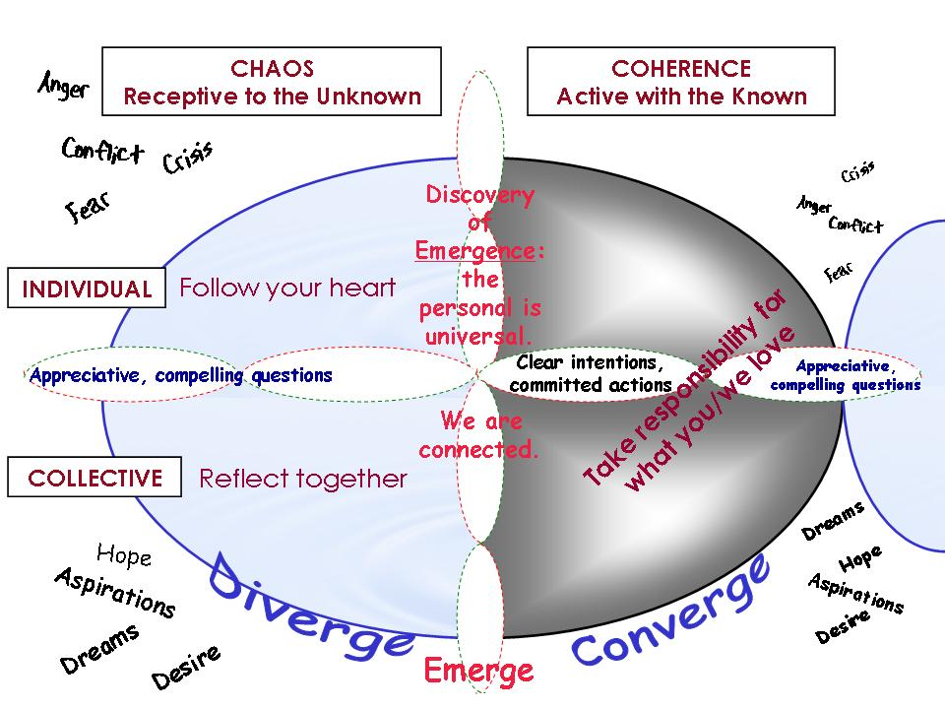

Figure 1. Diverge, Emerge, and Converge

This pattern of relationships among chaos and coherence, individuals and the collective arises through:

appreciative, compelling questions…
that spark divergence into the unknown…
to emerge connected in new ways that ignite innovative ideas…
and converge into coherent, clear intentions and committed actions.

It contains the seeds for new forms of organization and community.

Nourishing the Seeds of Inspired Organizations and Enlightened Communities
What causes these seeds to grow and evolve? The answer is oddly simple. Do it again. Better yet, do it continually. Ensure your focus not only attends to the visible outcomes – project ideas and plans, new teams and agreements – but also nourishes the invisible web of community that generated those actions. In the long run, nurturing the human connections ensures ongoing generativity, the continual creation of new ideas, projects and relationships. Having moved from chaos to coherence, new disturbances – conflicts and dreams – unquestionably arise. It is far easier to welcome disturbance when one knows one is in good company working towards shared dreams! Shared inquiry into hopes and dreams grows the capacity to invite diversity, let go of answers and step into the unknown. More equipped to hold dynamic tensions – short term/long term, individual/collective, profit/service – while staying connected to each other, inspiration and enlightenment become a way of being, not a destination. The more we embrace our differences, the more our capacity to recognize the opportunities inherent in what makes us uncomfortable grows. With practice, we become more willing, even enthusiastic, to take the vital step into the unknown.
It is the practice of caring for oneself, others and the whole that weaves and sustains the web of connections. By supporting people in tuning into personal meaning, sensing a heartfelt connection to each other, and feeling they are held by some larger purpose, a virtuous cycle of support grows. While many strategies can work, central to them is communication that connects – narrative rich, interactive, and transparent. Continually clarifying purpose, coming together as a community, and providing support for people to grow in their capacity to contribute also keeps the invisible web healthy and vital. These activities remind people that they are part of something larger, that they have kindred spirits who also care. And, as the journalists are discovering, when people care about what they are doing and with whom they do it, work gets done, even when the going gets tough.
With no formal infrastructure in place, some of the journalists who were inspired by the images that emerged of a new type of newsroom found the resources to reconvene and bring new partners into the mix. Six months later, 22 diverse journalists and citizens gathered around the question “What is the next news room and how do we create it?” The first evening, a deeper and clearer purpose emerged, sparked by a citizen participant: this wasn’t about a new newsroom at all; rather, they were envisioning a new news ecology. The insight was electric. The sense of community forged around this sense of purpose is bearing fruit – experiments in urban and rural communities are emerging. By staying connected to each other, these experiments become a learning laboratory, a community of communities growing the capacity of professional and citizen journalists for a new kind of journalism.

The Challenge and the Potential of Emergent Practices
Perhaps the most common block to using emergent processes is that it is virtually impossible to know the specific forms outcomes will take. This is because, emergence, by definition, involves the unknown. What lessens the risk and increases the likelihood of success is the clarity of intention guiding the work. This powerful combination – direction established with a question that focuses intention coupled with openness to the unknown creates a dynamic tension ripe for emergence. While it can be a leap of faith to believe great results come without defining the specific outcomes, if you want breakthroughs, a broad and deep delving into passion and purpose almost always far exceeds any pre-determined outcomes. Those who ultimately choose this route often do so because they are stuck but realize that continuing to act in the same way won’t produce the fundamentally re-generative results they seek.

The Evolution of What Emerges
A group’s diversity, an event’s duration, and ongoing experience shape the nature of what unfolds. In short homogenous events, new ideas, relationships, and connections are made. Two days and increased diversity can generate breakthrough ideas pursued by self-organized teams. Longer events often provide glimpses of the ongoing pattern of emergent leadership and structures. With multiple experiences, the pattern is internalized. Experiments in self-managed teams in organizations and citizen committees in communities frequently emerge. When embraced as an ongoing practice, people organize themselves following inspiration and commitment. Structures emerge to fit the context. New forms of governance are required when leaders are those who attract followers by taking responsibility for what they love.

Time and Diversity | What emerges
Less than one day, limited diversity | Ideas and relationships  (new connections)
At least two days | Special projects  (temporary structures and leaders)
Long events  (3-7 days) | Glimpses of emergent leadership and structures  (temporary experiences of fluid form, fluent leadership)
Multiple experiences | Self-managed teams and committees  (new structures, fluent leadership)
Ongoing pattern | Emergent organization/ community and governance  (fluid form, fluent leadership)

Table 1. The Evolution of Emergence

What happens when taking responsibility for what one loves becomes the norm?
It means people care for themselves, each other and the whole. Individuals consistently follow what has heart and meaning. The collective regularly connects with itself by reflecting together, remembering the meaning and purpose that nourishes the web of community. The resulting coherence supports individuals and groups in taking responsibility for what they love. I think of coherence as “differentiated wholeness” because it exists when there is space for the individual and collective, the inner life and the outer life. Being our quirky, unique selves while staying connected replaces our current cultural tendency towards conformity and isolation.
Many of us learned that to care for ourselves is selfish. Sacrifice and compromise are necessary for a working society. In practice, denying our own deep needs seems to generate a shallow ego-centricity. People disassociate from a deeply fulfilling connection to themselves. Selfishness and greed result as individuals and groups protect their own “interests”. Society fragments. .Feelings of scarcity surface. The web of connections disintegrates and the sense of wholeness is lost.
Contrast what happens when invited to ask oneself, “What is important to me? What do I care about so much that I am willing to take responsibility for it?” Internal attention shifts from ego to center – where head, heart, and spirit connect to guide us. Acting from center, differences cease to be barriers and become gifts that attract new connections. There is a feeling of abundance, as differences are integrated into new, fuller understandings of ideas and relationships. Oversimplified “us vs. them” positions are replaced by richly nuanced inclusion of differences. A more elegant simplicity is found through a better understanding of the true complexity of our individual and collective distinctiveness. This is truly differentiated wholeness in action.
Leadership emerges everywhere. Individuals, guided by their heads and hearts, act as “free agents.” They speak from their full voices. When that voice resonates with others, as if some universal Truth were spoken, people follow. What IS a leader after all, but someone who speaks a truth so compellingly it inspires others to join them? When this opportunity is widely available, a powerful and fluid field of leadership emerges in the collective.
When we collectively take responsibility for what we love, there is an unaccustomed openness in which our connections to each other form a “resonant network”. In truth, we are always connected. When we act from inner connection, we open to each other, and that connection is visible. In this web of community, people are more alive and effective, sharing their gifts with each other. They easily find others who care about the same things they do. The tension between the needs of each individual and the needs of the collective dissipate. We are in coherence. If one voice is dissonant, it no longer fragments the group. Instead, through attractive, appreciative questions, it is understood and integrated for the good of the whole.
When coherence is sustained, through continually tapping our sense of connection, the ripples are powerful. Newfound trust develops as breakthroughs in ideas, solutions, and relationships support both planned and emerging action. There is a greater willingness to be flexible. A virtuous cycle of ideas, connections and actions feed into even more exciting ideas, connections and actions. How might it resolve for the journalists? Beyond their gathering, what new possibilities were sparked by their time together? Here’s an imagineering story of where it could lead:

During the three-day gathering of journalists, new connections were made and projects defined. As the community experiments take shape, what might they look like organizationally, how might they affect the communities in which they operate?

Imagine the morning news meeting convened in the local café, open to whoever wishes to participate. The content for web, broadcast, and print for the day is selected as people reflect together on what best serves the community’s needs. Stories are pursued by people taking responsibility for what they love:

…A citizen journalist hears about a potential conflict between a social service agency and the people it serves. She recruits a professional journalist to investigate with her. Their first step is creating some powerful, appreciative questions to discover what is life-giving in the situation, so that the whole story is told.

…The local school board meeting is covered by a high school student as a community service project. The high school newspaper staff partners with professional journalists. Beginning with school and youth issues, as student skills increase, they cover broader community issues. And, of course, the growing population of young bloggers is engaged in all aspects of this community journalism work.

…A musician is listening and composing. He will travel to restaurants, cafés and street corners singing the news of the day.

…A professional journalist has just turned in his series on an emerging community trend in cross-cultural cooperation. Before the new news operation joined the community, there was little interaction among different ethnic groups. As people from the different parts of town met through gatherings convened by the news organization, they got to know each other. They realized knowing more about each other’s cultures would lead to greater trust and cooperation. It began with progressive dinners and sharing traditional foods. Now people are visiting each other’s places of worship. They’re even forming study groups to learn about each other’s beliefs. Some were inspired to set up a blog, an online newsletter, and podcasts to increase their reach within and beyond the community.

…A graduate student is interviewing several activists, journalists and politicians about the new movement in "action research journalism" in which investigative journalists team up with non-profit advocacy and research groups to investigate corporate or governmental abuses of power. Confronting the officials involved with the potential expose draws them into negotiations to correct their actions. Major deliberations with citizens and other stakeholders are underway to change the systems which make such abuse unattractive or unavoidable. Successful negotiations and deliberations become news stories of successful reform in which everyone wins. The would-be expose becomes mere background material eclipsed by the narrative of positive change. Commentator “Paul Hardey” dubbed this growing phenomenon "appreciative democratic blackmail."

One of the offshoots of action research journalism is that more officials are taking the initiative -- before any investigation happens -- to deal with difficult moral decisions proactively. They engage journalists in utilizing public dialogues, appreciative inquiries and community deliberations to work out acceptable -- and sometimes thrillingly creative -- approaches which are widely reported and credited to the initiating officials.

A feature of the news organization web site is the "tip jar” button. Both citizen and professional journalists benefit not only from feedback and interaction with their audience but feel acknowledged for a job well done. It has also proved a great recruiting tool for attracting citizen journalists.

That afternoon local journalists meet online with members of two other communities engaging in similar experiments. They’ve been approached by a new community that wishes to learn from their example. They discuss how to communicate the initial challenge of enticing people to become citizen journalists. After years of being a passive audience, it takes creativity and commitment for people to realize the benefits of getting involved.

The news organization has also just heard from a national broadcast news network which wants to explore a local/national partnership. As market share for national broadcast news continues eroding, networks have a new openness to learn from thriving community news operations. It is a long awaited opportunity to scale local learning for the national stage.

That evening, the editor and interested news organization employees meet with the citizen oversight board, a self-selected group who come together monthly to ensure the social, economic, and cultural needs of the community are met. Tonight they discuss the upcoming annual review inviting a randomly selected mix of citizens to provide feedback on how well the news organization is meeting the community’s needs.

This annual event has worked so well that the local Citizens for a Better Community group is working with the town council and the news organization to convene a similar event for the community. They plan to randomly select twenty citizens for a weekend of facilitated conversation to produce a consensus statement about the state of the community. The journalists will cover the selection process, who these very different participants are (so the community can identify with them) and how they change during their dialogue. Their findings and public discussions of them will also be covered. With repetition and good coverage, they expect the process to become a powerful way for the community to see itself. Dreams and concerns are voiced in a coherent way that everyone -- public officials, institutions, and the public itself – can engage.

On the other side of town that same evening, a citizen journalist is covering a town meeting on waste disposal. With increased trust among the community’s many ethnic groups, there is growing confidence that those who show up are acting in service to the whole. This has enabled people to follow the issues they care most about, knowing that others are doing the same on their behalf. This virtuous cycle of increasing trust and creative community engagement mediated by community journalism has attracted national recognition, and a national foundation has just informed the town that they have received an award as one of the most livable communities in the country.

What worked?
The constant practice in recognizing the potential inherent in disturbances and embracing them through asking powerful, attractive questions becomes the conscious way of working. When issues arise, someone takes responsibility to convene a gathering, inviting whoever cares to address it on behalf of the whole. There is growing confidence that when diverse people follow what has heart and meaning, when they reflect collectively, unexpected and innovative insights cohere into clear intentions and meaningful action.
My working definition of an inspired organization or enlightened community offers an answer to the oft asked but rarely answered question about transformation: “change to what?” What it is that we wish to become? This is my answer:
A system that consistently achieves what is most important to it, individually and collectively by…

continually increasing its capacity for emergence through…
people caring for themselves, each other and the whole…
in service to a meaningful purpose.

The practices, experience, and consciousness to do this are growing among us and around us. As more of us engage in this adventure, we can see this new way of being together clearly emerging as a vital trend. As the new century unfolds and the illusion of control continues eroding, this capacity for embracing the unknown will increasingly be recognized for its power to nurture emergence and self-organization -- and thus it will grow. As this happens, the possibilities become truly limitless.

Thanks to Tom Atlee (cii@igc.org) for the “action research journalism” examples.
Thanks to Nancy Margulies (nm@montara.com) for this idea.
Thanks to Tom Atlee for this paragraph.

